SACE Stage 2
Digital Technologies

Web Solution
Documentation


Student Number

INDEX

- Problem Definition 3

- Analysis 4
  - Outcome 1 4

  - Outcome 2 5

  - Outcome 3 5

  - Outcome 4 6

- Design 7

- Development and Validation 9

- Evaluation 10

- Project Client
The Australian Bureau of Statistics (ABS) have retained our services to recreate their website: https://www.abs.gov.au/ to optimise their presentation of statistical information as it has identified that it lacks a consistent, governed approach to managing current and archived data sets. The focus of the project is to recreate the homepage and develop a template for data records. A data set relating to offender rates is to be used to “mock up” the proposed new format. Key stakeholders for this project are:
- Australian Federal Government
- ABS
- Private individuals (people who use the ABS website for personal reasons)
- Corporate/Researchers who use the site for profit activities/research purposes
- Miscellaneous third parties who are seeking specific data sets available in the public domain.
The ABS is the primary client and decision-maker in relation to the project design specifications and delivery timetable.
- Design Specification
The site needs to address the following specifications to be considered complete:

- It must be “user friendly” and enable easy and intuitive navigation between pages/functions for new and former users.
- It must be able to receive information and display it in a clear and easily understood format.
- It must be secure to ensure data sets cannot be manipulated by non-ABS accredited workforce
- It must be transformable so it can work on multiple types of devices such as phone, tablet and computer.
As the website is public facing and its format is well understood by its user base significant changes to the functionality of the original website, for example, navigation tools, are to be avoided or minimised unless attempting to optimise site efficiency. Changing well established architecture can lead to confusion for users which may reflect negatively on the Bureau and reduce user engagement with the site. The ABS was particularly focused on avoiding the public backlash experienced by the Bureau of Meteorology, post the launch of its new website.

- Preliminary Design
The current ABS website homepage has been separated into multiple divisions - horizontal and vertical sections (see Figure 1). The first horizontal section is the banner with the ABS name, the next section is an overview of key data points relating to Australian population and financial information. The page is then divided into three columns providing access to latest/future releases, specific ABS information such as their strategy and Media Centre and then highlighted data sets, in this case “valuing nature’s contribution” and “life course data initiative”. The page then has a final horizontal division providing access to recent articles.

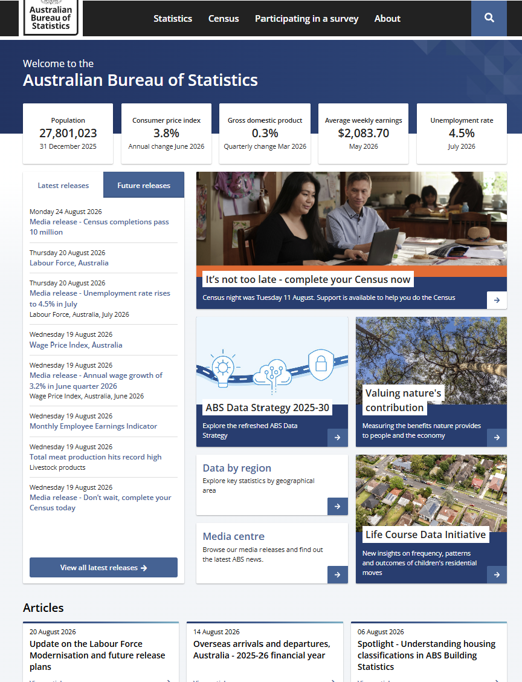
Figure 1: ABS homepage https://www.abs.gov.au

While comprehensive, the page is cluttered and may be difficult to navigate for individuals who are not used to this amount of data within a page or are not sure what they are looking for. Each data set is not delineated sufficiently which makes it harder for users to quickly identify what they are trying to access. The mixture of text and pictures with darker blue highlights also means user’s eyes are drawn first to the pictures and darker colouring potentially overlooking the lighter text. It would also be difficult to read for people with visual impairments.

The preliminary design (Figure 2) was focused on simplifying the presentation and navigation through the site to improve user experience and accessibility. The concept was to maintain the original site’s multiple divisions and aesthetic, for example, colours and font to ensure continuity of branding. The key data sets however, were to be spaced out across the divisions to avoid overlaps and allow users to clearly identify the nature of each data set and make the site easier to navigate. Use of the darker highlights were minimised and pictures were avoided making the text more prominent on the page and easier to see, particularly for visually impaired users.

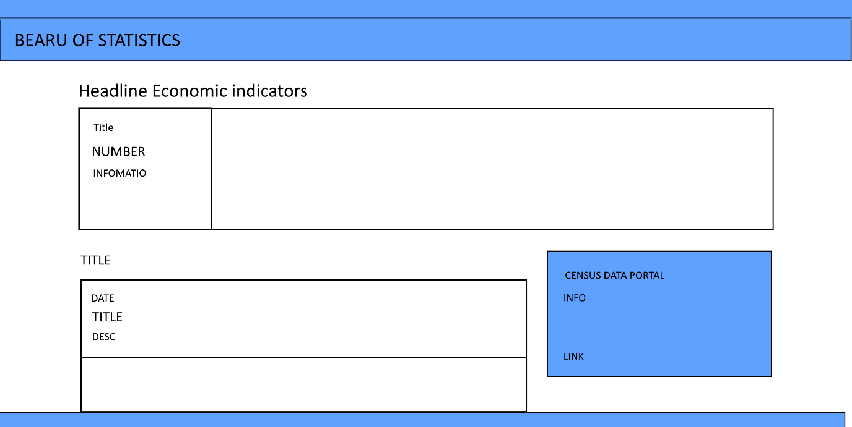
Figure 2 – mock up of the proposed design

The Group undertaking this project consists of two members. The roles for each member of the Group were originally allocated as:
- James – Programmer; Documenter, User Interface, and Tester.
- Ethan – Documenter and User Interface.
- Project Plan

The project had 3 weeks to complete development, programming, documenting and testing of the design. The Group determined that primary communication would be via meeting during lessons and emails, which was intended to provide a mix of face-to-face time for brainstorming and development plus follow up and answering of questions on emails. The timeline and deliverables outlined in Table 1 was developed to align with the communication strategy and project deadline.

Date | Itinerary | Achieved
3/08/2026 | Practical discussion (both Group members) | Outlined the basics of the tasks
4/08/2026 | UI discussion + structuring (both Group members) | Outlined how the UI will look in accordance with the ABS site. Created a barebones structure of the ABS site’s data.
6/08/2026 | Working on the structure and improvements (James) | Added upon the previous structure, improving it and fixing bugs.
7/08/2026 | Getting basic functionality into the website while adding upon the UI structure. (James) | Got basic functionality into the website while adding upon the UI structure.
16/08/2026 | Recode of the basic structure (James) | Recoded the entire website to be more accurate to the official ABS.
17/08/2026 | Readding functionality and finishing JS code (James) | Readded tables; graphs and fixed bugs.
21/08/2026 | Adding final functionality and adding all data (James) | Added all functionality and added most data.
Table 1 – project plan and timeline

Table 2 outlines the key deliverables and the expected timing of output to ensure the project deadline was achieved. This includes key points in the project that require client input and/or approval.

Timeline | Overview: | Description:
Week 1 | Basic Structuring | Creating the basic structure of the webpage.  Client input: Approve basic structure and design
Week 1 | Adding Basic Functionality | Implementing basic functionality including buttons; importing spreadsheets, displaying spreadsheets, and saving them.
Week 2 | Create User interface | Recreating the ABS site basic interface, whilst implementing changes to create a more streamlined experience.  Client input: Approve more streamlined interface
Week 2 | Clean Up | Cleaning up unnecessary or broken code.
Week 2 | Refine User Interface (UI) | Ensuring all UI can scale properly and is accurate to the original as to not confuse users.
Week 3 | Bug testing | The final line of bug testing to ensure no bugs slipped through the pipeline.  Client input: Approve final prototype
Week 3 | Finalise Webpage design and functions | Incorporate any client feedback and finalise design and functionality  Client input:
Table 2 – key project deliverables and timing

One of the key risks to the project was that the proposed design or functionality did not meet the needs or expectations of the client. To minimise the potential of this occurring communication with ABS was scheduled weekly or at the end of each key stage of work. The “Client input” included in Table 2 provided decision points which allowed the client to view and agree each key stage in the design and function development and meant that the risk that the project was moving in the wrong direction was reduced. Any feedback provided by ABS was discussed and agreed updates incorporated into the design/functionality in the next phase of development, allowing it to move through the development stages efficiently. Coding was also focused on ensuring the system behaved in a predictable and logical manner, which was tested as part of the testing phase.

Another key risk was that failure to deliver the project on time. As the project progressed James undertook the majority of development activities. This was an unplanned outcome but in order to progress the project it was deemed necessary. This did have a negative impact on the project deadline which was delayed by a week. This fact was communicated to ABS who approved an extension to the three-week timeline.

- Design

The key features that were the focus of the design are the homepage and article page which includes functionality supporting the development of:
- Graphs
- Tables
- Reports

Home page

The home page was built to align with the preliminary design (Figure 2) and create a clean and uncluttered page that is easy to navigate for users and utilises ABS’s branding and colours.
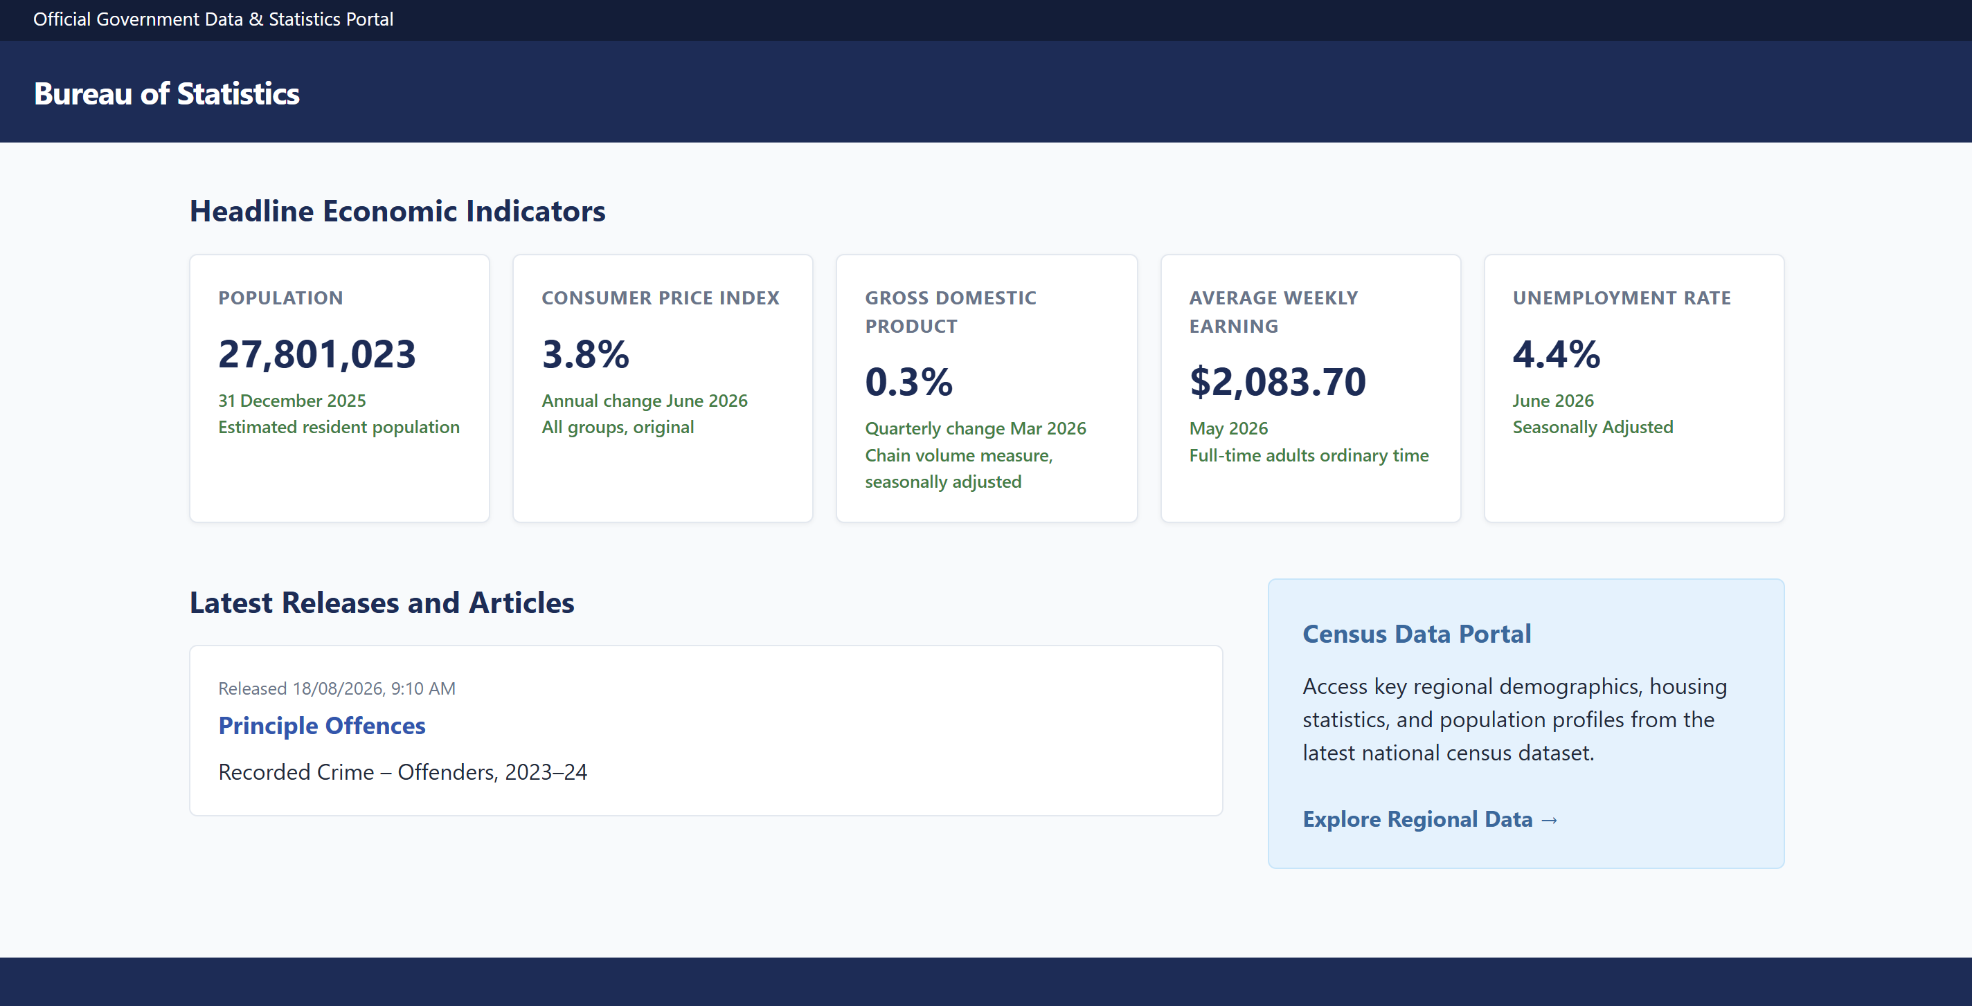
Figure 3 – Preliminary Design using ABS branding and data
A key feature of the home page is the banner which includes the ABS branding. This was made by adding a new “div” section to the webpage and giving it a class name “gov-banner” which meant it could have a different style to other parts of the page using style sheets. “Bureau of Statistics” was inserted by adding a header to the webpage. The body of the page was built using a <main> element, with sections titled using an <h2> styling class, for example Headline Economic Indicators in Figure 3.

The metrics shown under the section title, for example Population and Consumer Price Index in Figure 3, was shown as a horizontal grid by creating a <div> with the class name “metric-grid” and within this grid, another <div> with the class “metric-card” was added. This means that each metric card is an individual box displaying a specific statistic. ABS can change/update these statistics as desired. Inside each metric card a <h3> title and three smaller <divs> are inserted; a “metric-value” to display the primary statistic and one or more “metric-meta” classes to allow additional or supporting information to be included.

The content section, such as the Latest Releases and Articles in Figure 3 was created by using a <div> with the class “content-split”, which allows this section of the page to be divided into two vertical parts. To allow individual articles to be listed a <div> with a class “news-list” was created which acts as a repository for all articles and keeps them within one area of the content section. Each article in the list is created using a class “news-item” and has a “date”, “heading” (h4 element with a link <a> to the article data) and “paragraph” (<p> which provides a description of the article’s content).

The sidebar, such as the Census Data Portal in Figure 3, is created by using an <aside> element with an inserted <div> with the class “sidebar-box”. The “sidebar-box” has a heading (<h3> to label the section), a “paragraph” (<p> which provides a description related to the heading) and a link <a> which is a placeholder allowing ABS to insert a link to other relevant data.

Article page

The article page provides a mechanism for website users to access any publicly available data set from ABS. It is a template that individuals can use to search for specific statistical data and have it translated into text, figures or a table. The document reader extracts specific information from a database operated by ABS and splits the information into separate variables which can then be used by the graph creator or table creator to enable the development of tables or figures that can be accessed by website users. The data variables are preset by ABS and the output can only be developed from information contained within ABS’s database and not from third party sites. This is a security feature to ensure that ABS’s data cannot be manipulated or changed by third parties.

The architecture relies on three central categories of function:
- Data – JSON files within ABS database (held on temporary storage)
- Readers – access and fetch the data in the JSON files and declutter it via checkScript to make it more readily useable for the creator function
- Creators – create and/or modify elements by using hardcoded or fetched data from a Reader
While forming an integrated process flow, each component operates independently and movement of data is reliant on each component working to ensure data is displayed in accordance with the user’s requirements. Data is the critical category because if the database is not responding or communication between the database and the data component is not working than no further functionality can occur. As the data is within the ABS database, the key design features developed were the readers and creators.
Document Reader:

Once a user has identified the data set and outcome that is required, Document Reader begins by fetching the corresponding JSON file from the ABS database. The data within each JSON file is defined allowing the Document Reader, once it has a response, to separate the given data into corresponding variables such as titl; ldat, xdat, legn, type, sdat(s) and description. Once successfully separated, Document Reader then combines all the given sdat(s) into an array all_sdats and then passes each variable (except all the original sdat(s)) into ‘checkScript’.

checkScript:

checkScript was created to declutter ‘Document Reader’ and make a more unified area for functions that require data such tableCreate and makeGraph. The basic structure for checkScript is title, description and text definitions, function cells with data inserted, and adding text into definitions.

Table Create:

Table Create is a type of creator function with three core actions. It begins by locating elements by ID (“table-craft” and “table-title”) and defining these elements by “grabTable” and “grabTitle” respectively. It reads the text inside these elements and then overwrites the existing text content in grabTitle to the title passed from checkScript (txt). Utilising these actions enables ABS to change data in one unified location rather than having to make multiple edits across multiple pages if they update or archive any information.

Table Create then undertakes a Document Object Model (DOM) Manipulation loop using snam[obj]. It repeatedly finds a table element, creates a new <th> header cell with text from checkScript and sets that <th> content to the value snam[obj] and then inputs that <th> element into the table. By using a table element with ID it ensures that each loop always targets the correct table and by creating a new <th> element and appending it the table, it enables it to be built one row at a time. This means that table headers are generated automatically and the table layout can be scaled to the available data.

The building of table rows and cells are based on the use of the following data structures:
- xdat – an array of offence names that builds the rows
- snam – an array of category identifiers that defines the columns
- sdat – is an object that contains arrays of numerical values linked to a specific category. This provides the data of each cell.

The table is built using this data matrix renderer and when completed provides a table that has one row per offence, one column per category and cell values sourced from sdat[vari][obj]. For each value inside xdat, a new row is created called “newRow” and to ensure that it appends to the bottom of the table, the row is inserted at (-1). Inside each row, a cell called “tdOffence” is inserted into the row and given the text content of xdat[obj]. For each category a constant is created called “vari” and is used to access numerical data in sdat. This inserts a new cell at the end of each row and inserts content aligned with the relevant category (vari) and relevant offence (obj) in sdat.

To complete the table, a final row is created at the bottom which calculates a total for each category in snam by inserting a new cell at the end of the totals row called “tdNumber”. This cell allows each value in the category’s dataset to be aggregated until a total for the category is determined (totalDataResult). Once the totalDataResult has been determined it sets the tdNumber text content for that category. A new tdNumber and totalDataResult is created for every category in the data set.

This approach was adopted to provide ABS with a secure and dynamic mechanism to build tables that are predictable and accurate using data sourced from ABS’s database. By utilising a loop through xdat, snam and sdat, the table structure is driven by the available data and is scalable without requiring a change in code. Finally, separating the data, structure and looping/total functionality makes the code easier for ABS to maintain and adjust to changing requirements.

Make Graph:

If a user wants to create a chart the makeGraph creator function is utilised. Essentially its role is to draw a graph on the screen by providing data from the ABS database to Apache ECharts and utilising its graphing functionality to create the chart.

Apache ECharts is a free, open-source JavaScript data visualization library used to build interactive charts and graphs for web browsers. It is a good option for ABS as it provides multiple charting options, aligns with the data workflow used (loop through arrays xdat, snam and sdat) and provides interactive options which enhance user experience. Once the data is provided, the ECharts tool does the rendering and layout without ABS needing to develop and manage additional code.

To create a graph, the function begins by defining an element as ‘myChart’, finding it with a given ID and initialises ECharts. ECharts builds a graph based on a variable “options” which requires categories including title (what the graph is called), tooltip (interactive pop up), legend (what graph represents), X axis (category or time label), Y axis (measurement) and series (requiring a ‘name’; ‘graph type’ and ‘data’). To allow flexibility these categories could be left blank and the charting function would still work.

- Development & Validation

In order to ensure the preliminary design was going to meet ABS’s objectives, each function was tested to ensure it was reliable and delivered the expected features. As part of the project plan, ABS was required to approve the functionality prior to finalisation. An overview of the testing approach, outcome and enhancements/ solution upgrades for each function is outlined in table 3 below:

Design Function | Key Features | Testing Approach | Outcomes | Enhancements/Solution
Document Reader | Fetches data (JSON files) and converts it into usable variables while passing the information to checkScript. | Tested by layering alerts for specific variables and functions  - Alert given for each successful outcome  - process would not complete if there was a failure in a step | Testing demonstrated that Document Reader could not successfully fetch data when not using a live server. | A plugin called “Live Server” was implemented
checkScript | Uses data given by Document Reader and changes titles and descriptions to the given data while initialising makeGraph and table Create | Testing formed part of general debugging of other functions as it is a channel for data to flow between multiple functions. | As Creator functions operated reliably all data elements were being delivered in accordance with requirements. | No enhancement required.
tableCreate | A creator function which creates a table based upon the passed data from checkScript. | Tested by layering alerts for specific variables and functions  - Alert given for each successful outcome  - process would not complete if there was a failure in a step | Significant bugs were identified including:  - Categories generating on the right side or middle not left  - snam or xdat called position would be out of range or inaccurate  - Table would not create due to incorrect elements/data | Solution was revised to:  - Fix [obj] and [vari] position in line 113  - Rewrote and rearranged how data displayed to guarantee categories were loaded first (lines 99 – 115)
makeGraph | A creator function which creates a graph by using data passed from checkScript using Echarts. | Tested by layering alerts for specific variables and functions  - Alert given for each successful outcome  - process would not complete if there was a failure in a step | Significant bugs were identified including:  - Categories not being generated  - Incorrect naming schemers | Solution was revised to include more series in “options” (lines 147 – 188)
Table 3 – Function testing approach and solution changes/enhancements

- Evaluation

Once finalised and delivered to the client the project was evaluated against four criteria:
- Client objectives
- Design aesthetics
- Design reliability and architecture
- Project management

Table 4 examines the project’s performance across these four domains and identifies strengths and opportunities for improvement that could be considered in the future to further enhance functionality, user experience and maintenance.

Criteria | Key Features | Evaluation: Positive | Evaluation: Areas for Further Development
Client Objectives: Design Specifications | - “user friendly” and easy to navigate  - information displayed in a clear and easily understood format  - secure to ensure data sets cannot be manipulated by non-ABS accredited workforce  - transformable so it can work on multiple types of devices such as phone, tablet and computer. | - Webpages simplified and categorised to improve navigation and useability  - Coding designed to scale to available data  - Use of ABS database reduced opportunity for third party intervention  - Maintained ABS branding identity and colour palette  - Coding designed to allow webpages to be transformed on various types | - Allow JSON file to edit the structure of the article page to increase adaptability/flexibility  - To increase accessibility, have a voice activated option to interact with the webpages  - Integrate additional interactive features on webpage such as chatbot, article categories and a search function for articles
Design Aesthetics | - Use ABS branding and colours  - Provide a “clean” and uncluttered page  - Maintain features of original site  - Enable users of the webpage to easily identify information they need | - Webpages simplified while still being aligned to the original.  - Stylesheet refined for accuracy and clarity.  - Webpage elements spaced and sized to eliminate overlapping.  - Webpage basic design and schema refined to replicate the ABS. | - Integrate additional interactive features on webpage such as chatbot, article categories and a search function for articles without losing the “clean” feel of the pages
Design reliability and architecture | - Secure  - Coding easy to maintain  - Multiple options to display data  - saleability | - Webpage data is archived and secured inside the ABS’s restricted server.  - Webpages functions and variables are clearly named and defined  - Use of Apache ECharts to build charts as a very well tested and secure platform  - Architecture allowed data flow to move efficiently from source to final display with no noticeable lag times  - Testing using layered alerts made debugging more efficient | - Comments to allow for quicker evaluation.  - Offloading the table creation to the server and sharing the result.
Project Management | - Communication  - Delivery of design by deadline  - Testing  - Management of actions according to the project plan | - Testing effectively identified bugs, logic gaps, illogical statements and opportunities to refine page design  - Project Plan developed and identified key project milestones | - Communication pathways should be formalised to support improved allocation of work  - Delivery of project impacted by unplanned delays/conflicting priorities of one member of the team
Table 4 – Evaluation of Project

